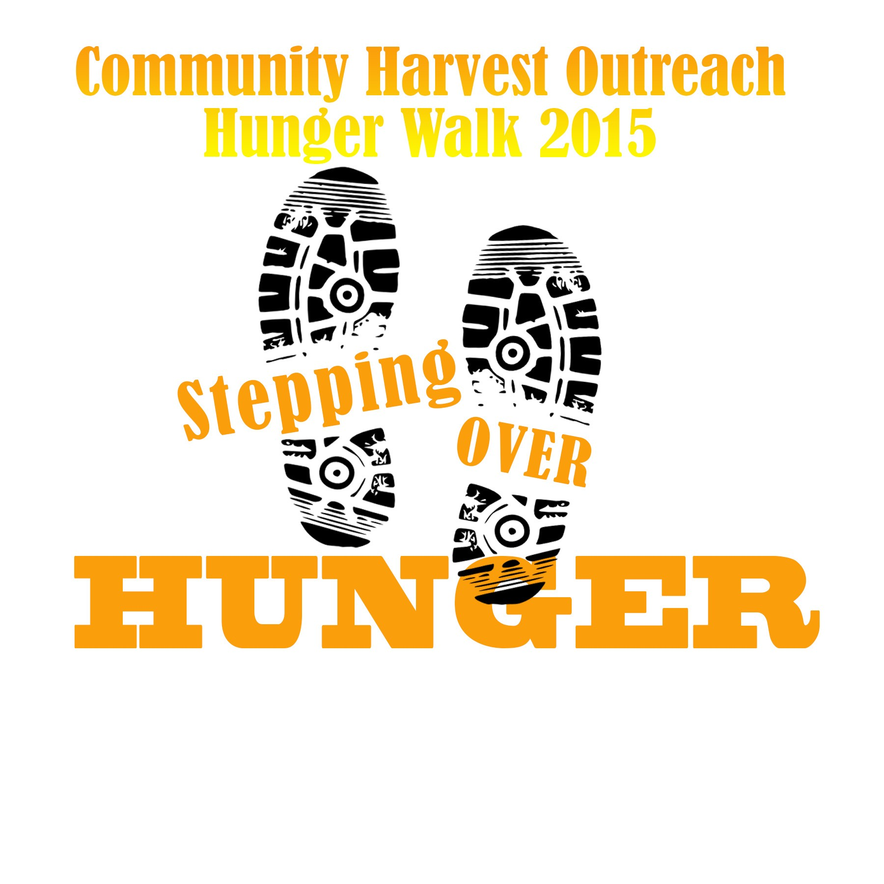
Community Harvest Outreach, Inc.
Hunger Walk 2019
Registration Form
Saturday May 25, 2019 12pm-1pm
N. Court St & Courthouse Hwy
Windsor, VA 23487

Complete and Email to communityharvestoutreach@gmail.com OR
Mail Registration Forms to P.O. Box 533 Windsor VA 23487 by April 22, 2019

Please Print Clearly

Type of
Walker
 Individual
 Corporate Walking Team Team Name:
 Private Walking Team

First Name Last Name Phone ( ) Address Apt.
City State Zip Donation $

E-mail
Event Waiver
In consideration of my participation in the Hunger Walk, I hereby assume all risks associated with the Hunger Walk and hereby release and agree to hold harmless Community Harvest Outreach, Inc., event sponsors, and their respective employees, directors, officers, representatives, agents, successors, assigns and affiliates (“Community Harvest Outreach, Inc. and its agents”) from any and all liability, actions, claims, damages, losses and/or injuries, including but not limited to loss or injury to property or to person, that I, my beneficiaries, administrators, and executors have, had or may have in the future, arising from or relating in any way to: (i) my participation in the Hunger Walk, including as a result of other participants and the weather; or (ii) any use of my name, photograph or likeness, as authorized below, including without limitation, for libel or any distortion or alteration of my photograph or likeness.

I hereby grant Community Harvest Outreach, Inc. and its agents the right to take my picture and to use my name, photograph and likeness for advertising, trade or other purposes, without further compensation or permission. I hereby assign any rights I may have in the photographs and acknowledge that Community Harvest Outreach, Inc. and its agents shall own all rights, title and interest in any materials created, and I waive any right I may have to further inspect or approve of such materials.

Signature Date

Parental/Guardian Waiver and Consent (Required if Participant Is a Minor)
By signing below, I acknowledge that I have read or have had read to me and understand the contents of this Event Waiver, expressly grant the child or children whose name(s) is/are represented below permission to participate in the Hunger Walk, and agree that the terms of the Event Waiver shall be binding on me and any children named on this form.

Parent/Legal Guardian’s Signature Date Children’s Full Names (First and Last Name)
1. 2.

3. 4.

